EFFECTIVE IMMEDIATELY
August 15, 2022
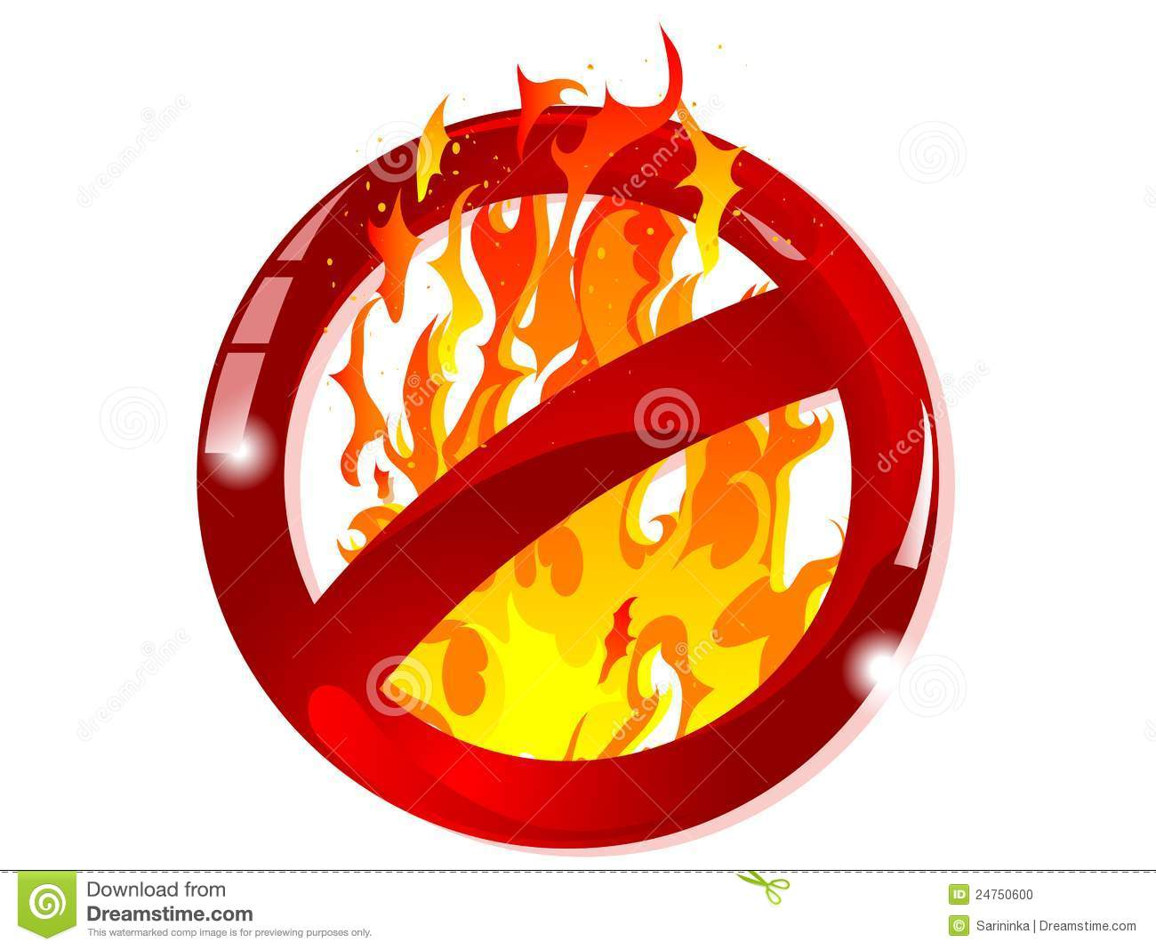
A FIRE BAN is in Effect

for the
R.M. of Swift Current No. 137
This Ban will be in effect until further notice

